KSUB -

Functionality
Assessment is a method of internal cost allocation by which you allocate (transfer) costs from a sender cost center to receiver CO objects (orders, other cost centers, and so on) using a secondary –assessment- cost element.
In the scenario, planned costs are assessed from the general cost centers to the R&T cost center using fixed (US dollar) amounts.

Scenario
The document shows how to execute an assessment cycle.

Requirements
Assessment cycle has been maintained for the upcoming planning year.

Menu Path | Accounting → Controlling → Cost Center Accounting → Planning → Allocations → KSUB - Assessment → KSUB - Assessment
Transaction Code | KSUB

1. Double Click on KSUB - Assessment

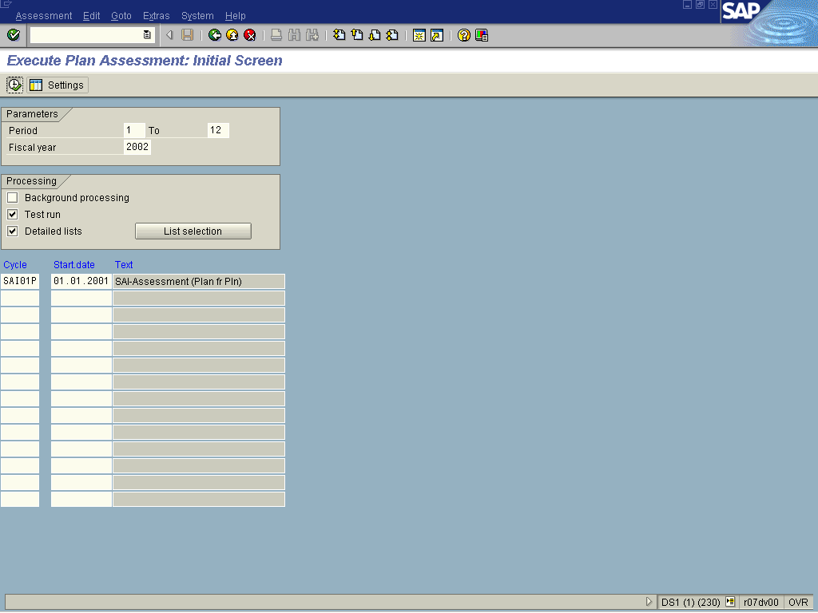

2. Update the following fields:

Field Name | Field Description | Values
From Period | Number identifying a fiscal month | Example: 01
To Period | Number identifying a fiscal month | Example: 12
Fiscal Year | Current Fiscal Year | Example: 2002
Cycle | Periodic repostings, assessment, distribution, and indirect activity allocation are defined using cycles. | Example: SAI01P

3. Click Execute

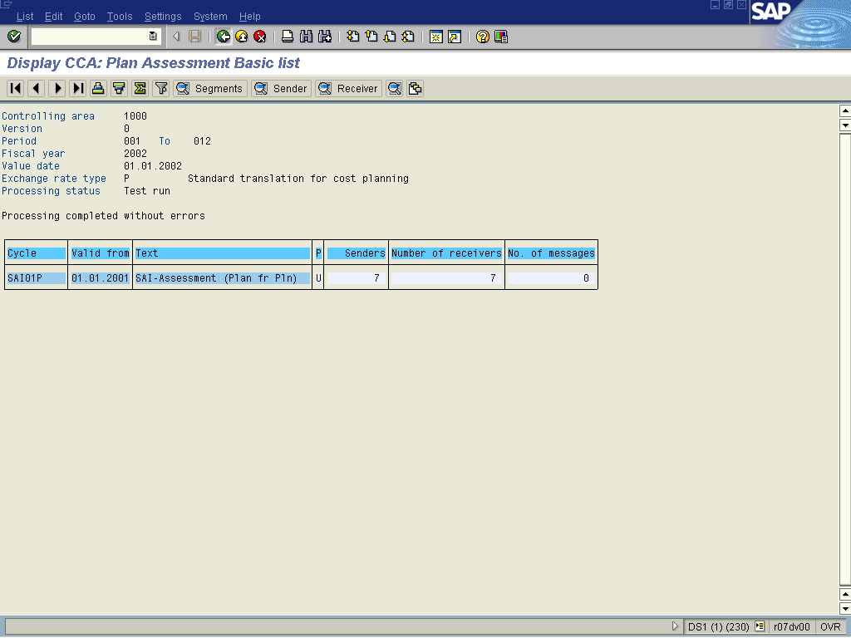
4. Click Back .

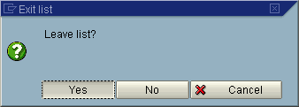

5. Click <tab button> Yes .

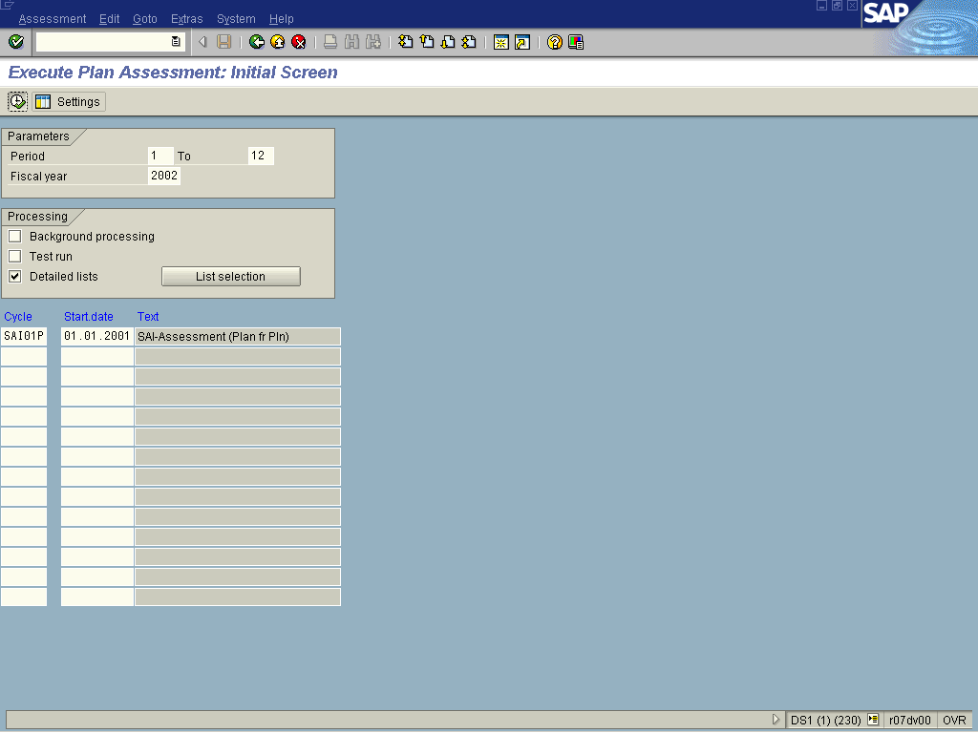
6. Click <checkbox> Test run .
7. Click Enter .
8. Click Execute.

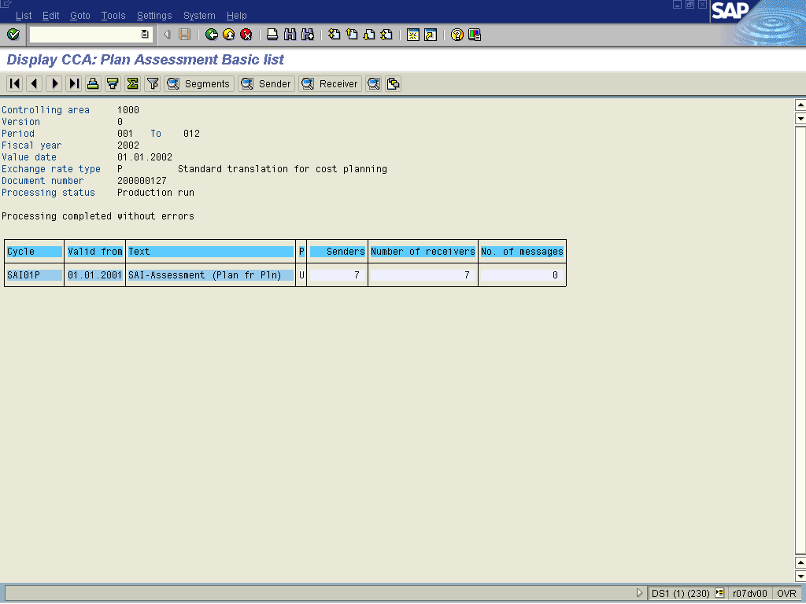

 To see the Sender Cost centers click on the Sender button . Alternatively to see a list of receiver cost centers, click on the Receiver button . For details, on both sender and receiver cost centers, double click on the relevant line item in the list.
9. A system generated list is displayed.

